SUPPORTING DIAGRAMS & FLOWCHARTS — PART 2
UI Screen Mockups, Random Forest Ensemble Diagram, and Feature Importance Chart (Figures 14–25)
College Timetable Management System with Intelligent Clash Detection and Resolution
Repository: github.com/Krishp285/timetable-clash-resolution

This is the second companion document, continuing directly from the first (Figures 1–13, architecture and UML/DFD diagrams). It provides Figures 14–25: wireframe mockups of every application screen listed in the report's List of Figures, a Random Forest ensemble illustration, and a feature-importance chart.

IMPORTANT — READ BEFORE USING THESE IMAGES
Figures 14–23 below are wireframe mockups, not real screenshots. Every one of them is stamped 'WIREFRAME MOCKUP — NOT AN ACTUAL SCREENSHOT' in its bottom-right corner for exactly this reason: I have no access to your running application, so I cannot capture genuine screenshots of it. These mockups instead reproduce, as closely as possible, the actual layout, fields, and data described in the project's README and templates (branch/division/subject/time-slot management, the side-by-side timetable-creation screen with live faculty availability, the ML risk badge and recommendation panel, the faculty dashboard and profile, the final timetable grid, and the clash log) so that the report has a visually complete, structurally accurate placeholder set.
To replace any of them with the real thing: run the application locally (Appendix B of the main report), open the corresponding screen, and take an actual screenshot — then simply swap the image in the document. If you'd like, I can also remove the mockup watermark for any figure you plan to keep as-is for a draft submission, though I'd recommend replacing these with genuine screenshots before final submission, since presenting mockups as real screenshots would misrepresent the finished product.
Figure 24 (Random Forest Ensemble Diagram) and Figure 25 (Feature Importance Chart) are technical illustrations rather than screenshots. Figure 24 is a conceptual illustration of how a Random Forest Classifier reaches a decision — it is schematic, not a rendering of the actual 100 trees in the trained model. Figure 25 is explicitly labelled illustrative: the project repository does not publish exact feature-importance values, so the bars show a reasonable qualitative ranking rather than measured output from model.feature_importances_. If you have access to the trained clash_predictor_model.pkl, you can recompute and substitute the exact values in minutes (see the note printed on the chart).

FIGURE 14
Referenced in: Chapter 5, Section 5.7 / Chapter 9, Section 9.2
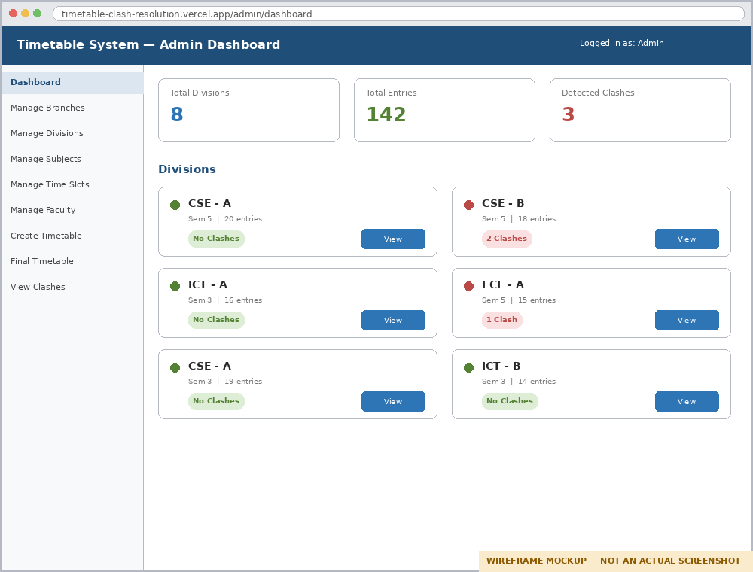
Figure 14: Admin Dashboard (Mockup)
A mockup of the Administrator's landing dashboard: summary cards for total divisions, total timetable entries, and detected clashes, followed by a grid of division cards each showing a green/red clash indicator, entry count, and quick-action buttons, matching the behaviour described in Section 5.7.

FIGURE 15
Referenced in: Chapter 5 / Chapter 4, Section 4.6
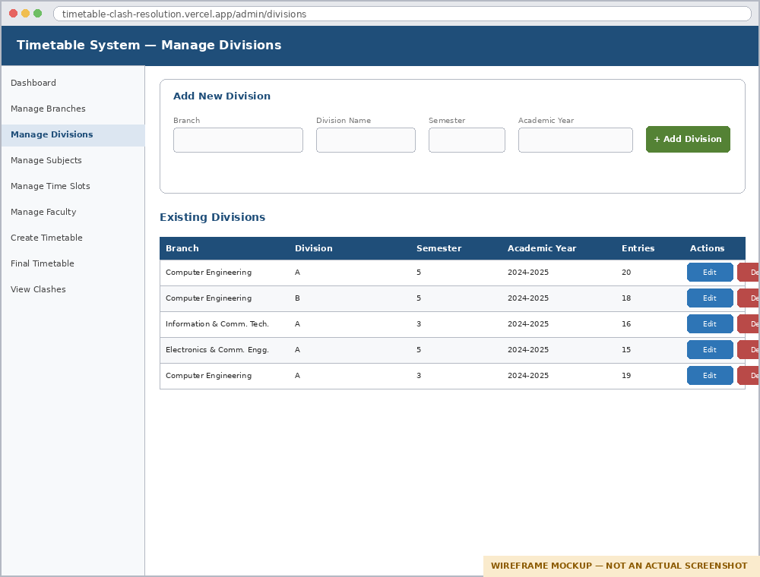
Figure 15: Manage Branches / Divisions (Mockup)
A mockup of the division-management screen: an 'Add New Division' form (branch, name, semester, academic year) above a table listing existing divisions with edit/delete actions, reflecting the divisions table schema in Section 7.4.4.

FIGURE 16
Referenced in: Chapter 4, Section 4.8 / Chapter 5, Section 5.8
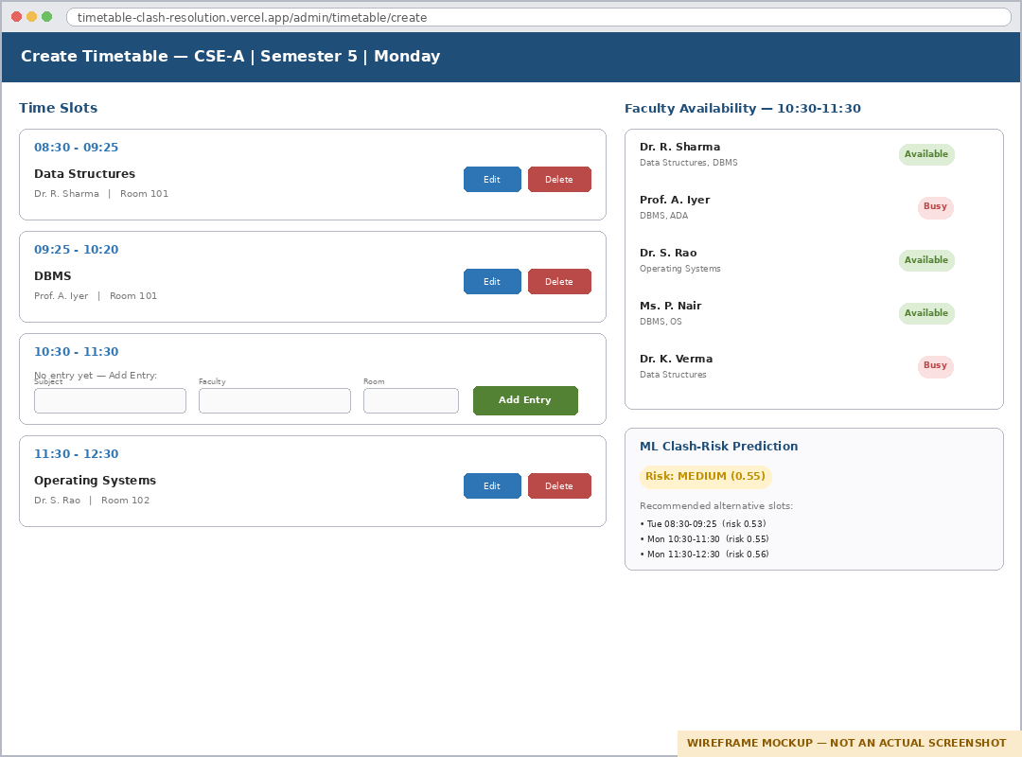
Figure 16: Timetable Creation (Side-by-Side) (Mockup)
A mockup of the core timetable-creation screen: time slots and existing/empty entries on the left, and the live Faculty Availability panel plus the ML clash-risk prediction and recommended-slots panel on the right, matching Figure 3 in the main report's design description.

FIGURE 17
Referenced in: Chapter 5, Section 5.8
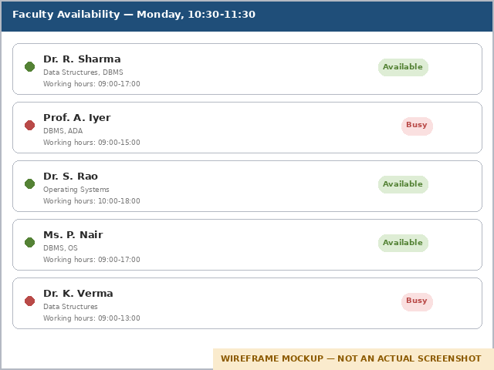
Figure 17: Faculty Availability Panel (Mockup, close-up)
A close-up mockup of the faculty-availability panel shown alongside timetable creation, listing each candidate faculty member's name, subjects taught, working hours, and an Available/Busy badge for the currently selected time slot.

FIGURE 18
Referenced in: Chapter 6, Section 6.12 (Algorithm 6.2)
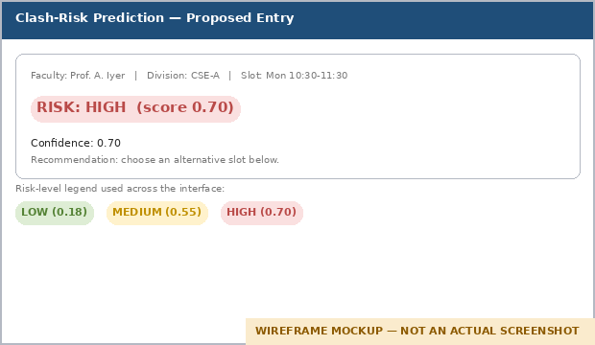
Figure 18: ML Risk Prediction Badge (Mockup, close-up)
A close-up mockup of the clash-risk badge returned by /api/ml/predict-clash-risk for a proposed entry, together with the low/medium/high colour legend used consistently across the interface, corresponding to the risk_score, risk_level, and confidence fields described in Algorithm 6.2.

FIGURE 19
Referenced in: Chapter 6, Section 6.13
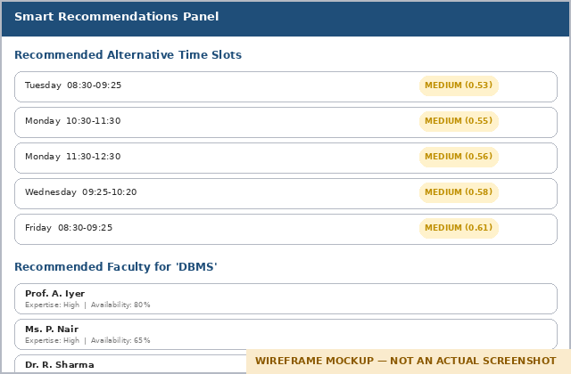
Figure 19: ML Recommendations Panel (Mockup, close-up)
A close-up mockup of the recommendations panel showing the top-five lowest-risk alternative time slots (from /api/ml/slot-recommendations) and the top-ranked faculty candidates for a subject (from /api/ml/recommend-faculty), each with their scoring detail.

FIGURE 20
Referenced in: Chapter 5, Section 5.4
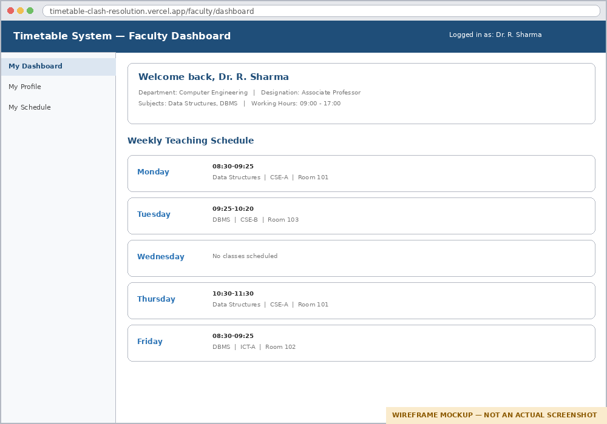
Figure 20: Faculty Dashboard (Mockup)
A mockup of the Faculty portal's landing dashboard: a welcome header with department/designation/subjects/working-hours summary, followed by a day-by-day weekly teaching schedule, matching the personal-schedule view described for the Faculty role.

FIGURE 21
Referenced in: Chapter 4, Section 4.5 / Chapter 5, Section 5.6
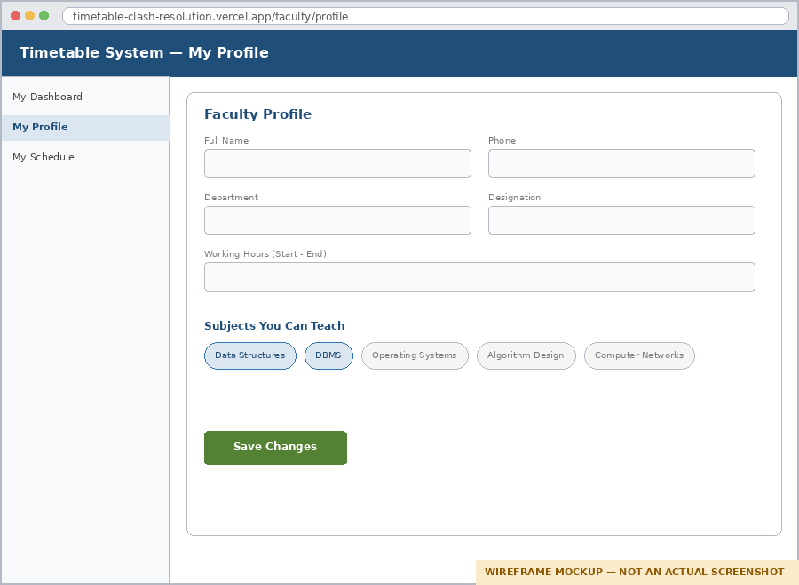
Figure 21: Faculty Profile (Mockup)
A mockup of the faculty profile-editing screen: name, phone, department, and designation fields, a working-hours range, and a multi-select chip list of subjects the faculty member can teach, matching the Faculty model's working_hours and subjects_can_teach JSON fields (Section 7.4.2).

FIGURE 22
Referenced in: Chapter 5, Section 5.10
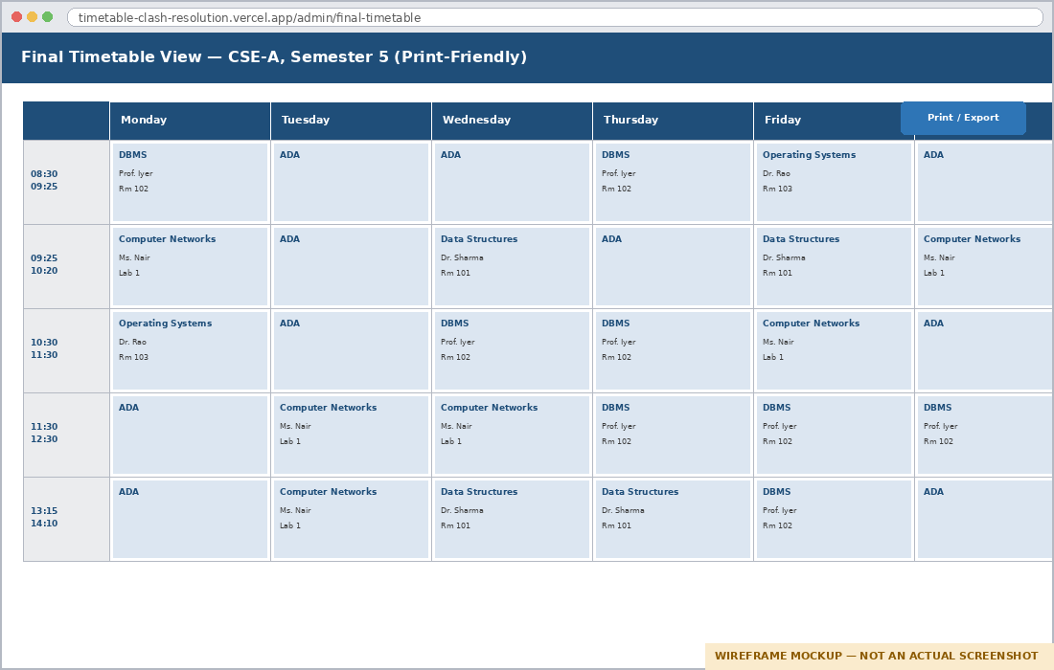
Figure 22: Final Timetable View (Mockup)
A mockup of the consolidated, print-friendly weekly timetable grid for a division, with days as columns and time slots as rows, each populated cell showing subject, faculty, and room, as described for the Final Timetable View in Section 5.10.

FIGURE 23
Referenced in: Chapter 5, Section 5.10 / Chapter 7, Section 7.4.8
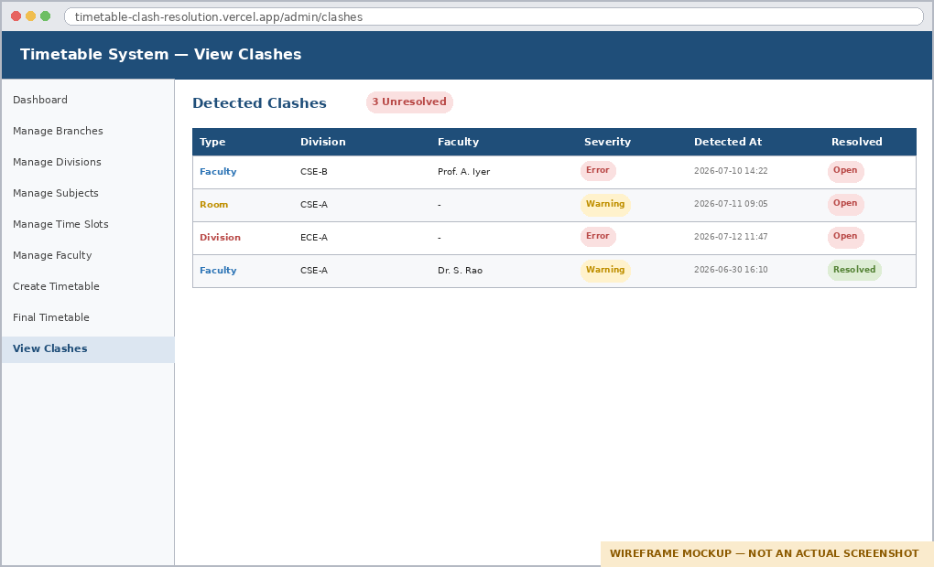
Figure 23: View Clashes (Mockup)
A mockup of the clash-log review screen: a table of detected clashes with type (faculty/room/division), affected division and faculty, severity, detection timestamp, and resolution status, reflecting the clash_logs schema in Section 7.4.8.

FIGURE 24
Referenced in: Chapter 6, Section 6.12 (Algorithm 6.2) / Chapter 2, Section 2.9
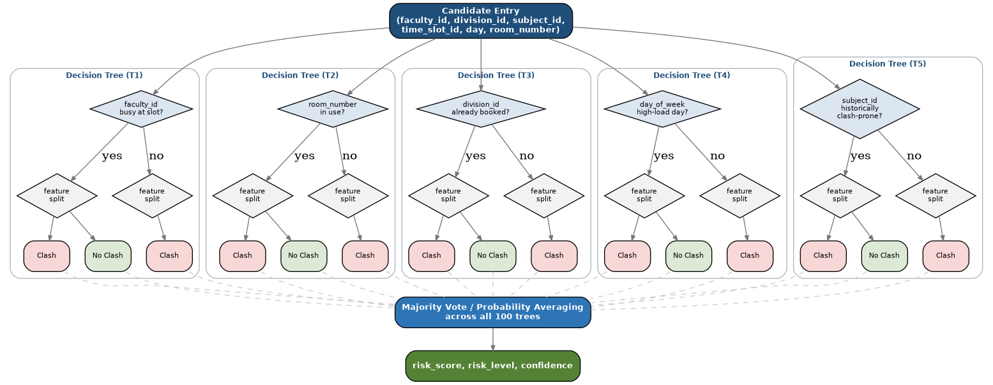
Figure 24: Random Forest Ensemble Diagram (Conceptual)
A conceptual illustration (not an exact rendering of the trained model) of how the Random Forest Classifier reaches a clash-risk decision: the six input features are passed to a forest of decision trees, each independently voting Clash / No Clash on illustrative feature splits, with the final risk_score, risk_level, and confidence produced by aggregating (majority-voting / probability-averaging) across all 100 trees.

FIGURE 25
Referenced in: Chapter 6 / Chapter 9, Section 9.5
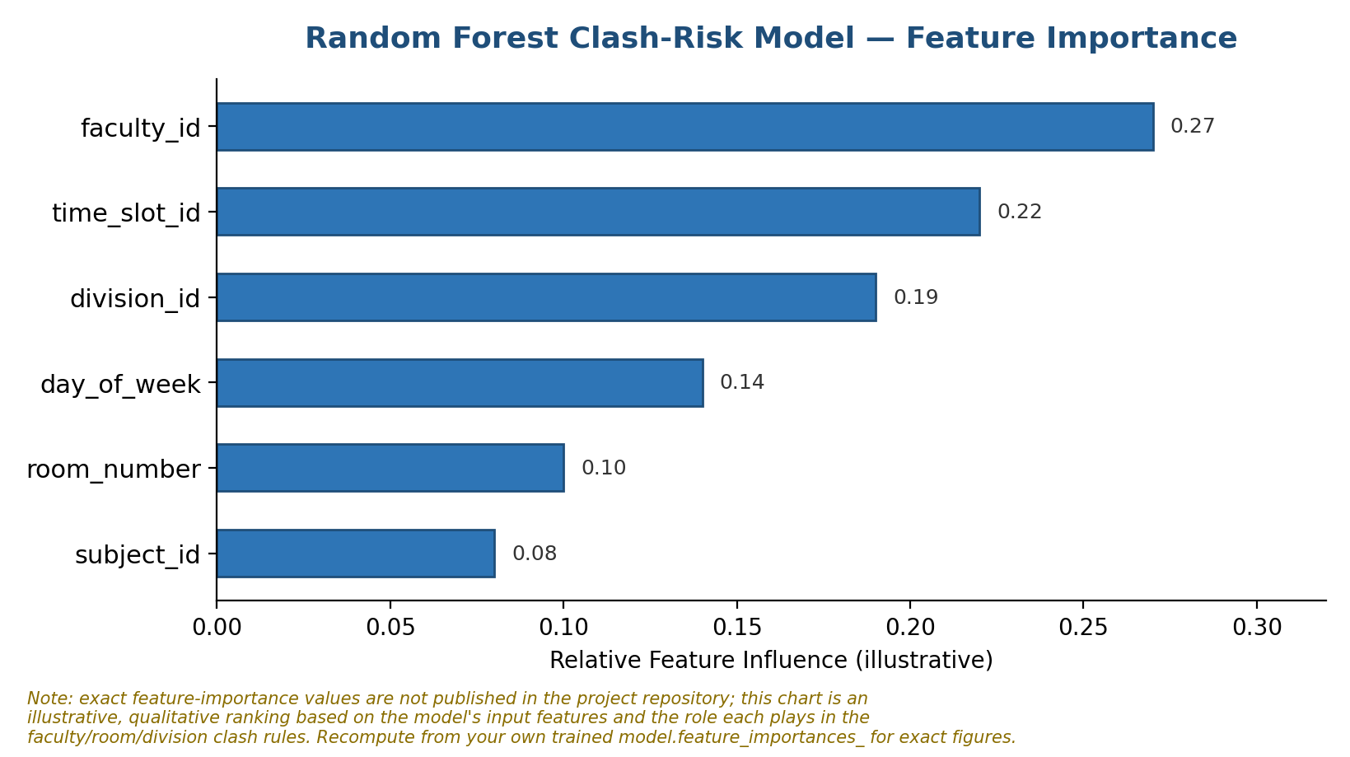
Figure 25: ML Feature Importance Chart (Illustrative)
An illustrative, qualitative ranking of the six input features by their likely influence on the clash-risk prediction, based on the role each plays in the faculty/room/division clash rules. Exact importance values are not published in the project repository; they can be computed directly from the trained model's feature_importances_ attribute and substituted here.

